**IST370**

**Lab 9 (40 points)**

**Theme: Single-Row Functions**

Run the following code prior to running your queries:

**SET LINESIZE 150**

**SET PAGESIZE 150**

**1. Create a query to address the following requirements:**

* One way to determine where a customer resides is to look at the first three numbers of the zip code. The United States Postal Service assigns the first three digits of the zip code to a geographical distribution area in each state. The Marketing Department can use this data to determine where to target certain promotional campaigns. For this purpose, produce a list of each customer number, complete zip code, and the **first three digits** of the zip code.

SELECT DISTINCT zip, SUBSTR(zip, 1, 3) "Distinct Code"

FROM customers;

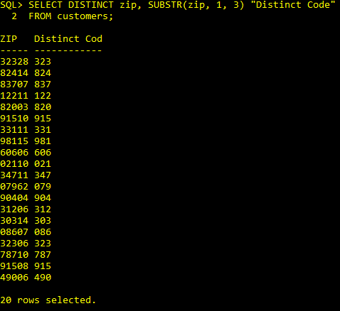

* As a special business requirement, the query out also include **the last two digits** of the zip code.

SELECT DISTINCT zip, SUBSTR(zip, 1, 3) "Distinct Code", SUBSTR(zip, -2, 2) "Code2"

FROM customers

WHERE SUBSTR(zip,-2,2) <100;

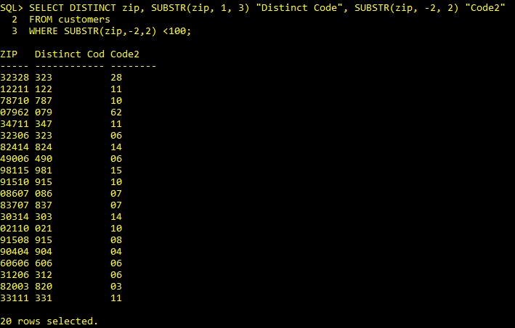

* An email address such as *John.Smith@example.com* is made up of a local-part, an @ symbol, then a case-insensitive domain. The query output should include each customer's complete email address, local-part, and domain.

SELECT email, SUBSTR(email, 1, INSTR(email, '@')-1) LOCAL_PART,

SUBSTR(email, -7,7) EMAIL_DOMAIN

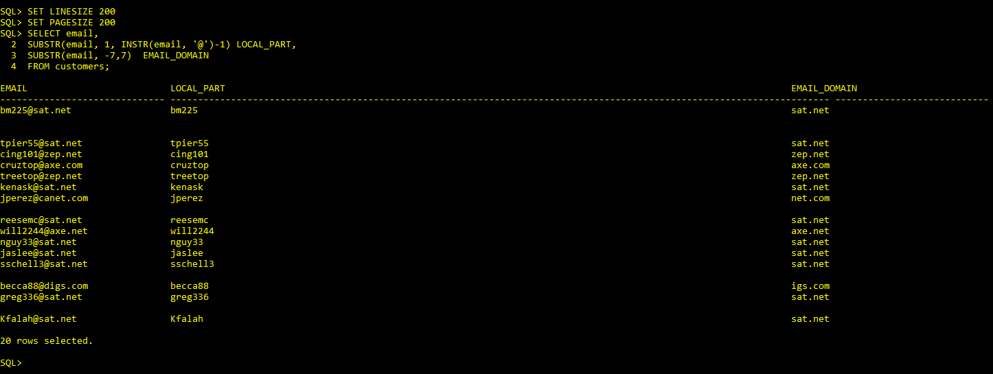FROM customers;

DISTINCT firstname || ' '|| lastname "Customer name",

zip,

SUBSTR(zip, 1, 3) "Distinct Code",

SUBSTR(zip, -2, 2) "Code2",

email,

SUBSTR(email, 1, INSTR(email, '@')-1) LOCAL_PART,

SUBSTR(email, -7,7) EMAIL_DOMAIN

FROM customers;

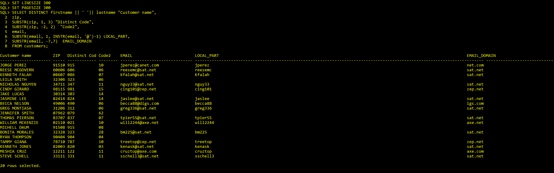

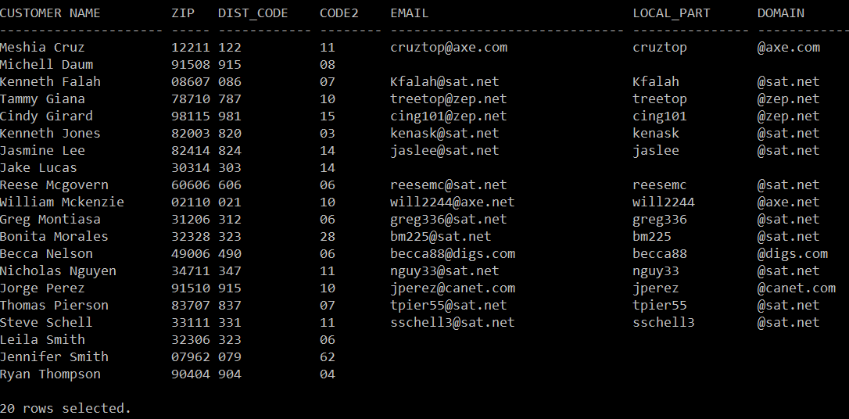

2. Create a list of all customer numbers and order number, along with text indicating whether the customer has been referred by another customer. **Display the text “NOT REFERRED” if the customer wasn’t referred to JustLee Books by another customer or “REFERRED” if the customer was referred**. The customer names should be listed in the way that the first letter of the first and last names is **in uppercase and the rest are in lowercase**. Sort the result in the descending order of REFERRAL and ascending order of last name.

SELECT DISTINCT c.firstname || ' '||c. lastname “Customer name”,

o.order#,

NVL2(TO_CHAR(referred), 'Referred', 'Not Referred') AS "Referral"

FROM customers c, orders o

WHERE c.customer# = o.customer#

Order by "Referral" asc;

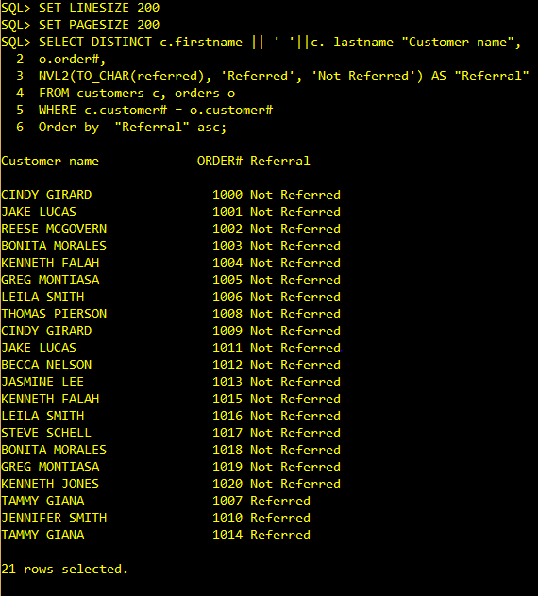

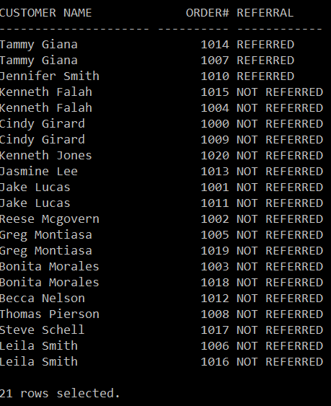

3. List all the orders with order# and shipdate. Display “Not shipped” under the shipdate column for those orders that have not been shipped. Also show the delay between the ship date and order date for each order in terms days and months.

Sort the result in the descending order of lead time and ascending order of customer# and order#.

SELECT c.customer# "C#", order#,

NVL(TO_CHAR(shipdate), 'Not Shipped') "Ship Date",

TRUNC(shipdate) - TRUNC(orderdate) "Lead Time (Days)",

ROUND(MONTHS_BETWEEN(shipdate,orderdate),2) "Lead Time (Months)"

FROM customers c, orders o

WHERE c.customer# = o.customer#

ORDER BY shipdate desc;

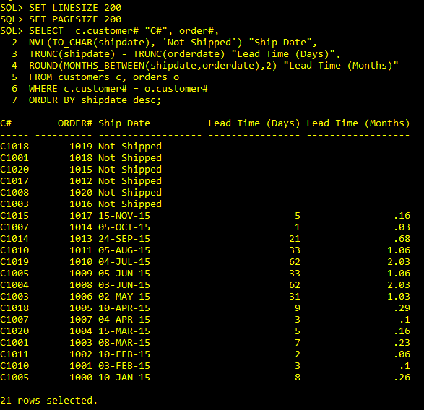

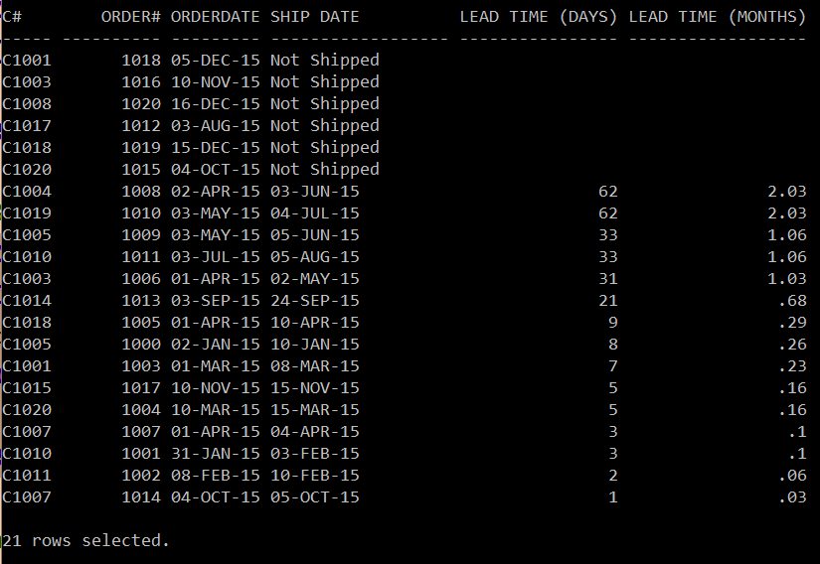

4. Determine the amount of profit for each computer book on variable orders. The profit should be formatted to display **a dollar sign and two decimal places (e.g., $999,999.00).** Sort the outcome in ascending order of profit.

***Total Profit = quantity * (paideach – cost)***

SELECT c.customer# “C#”, o.order#, DISTINCT title, pubdate TO_CHAR(PUB_DAT(pubdate), ‘ MONTH DD-DAY-‘) PUB_DATE,

TO_CHAR(oi.quantity*(oi.paideach-b.cost), '$999.99') “Profit”

FROM customers c, orders o, books b, orderitems oi

WHERE oi.ISBN = b.ISBN

AND o.customer# = c.customer#

AND category = 'COMPUTER';

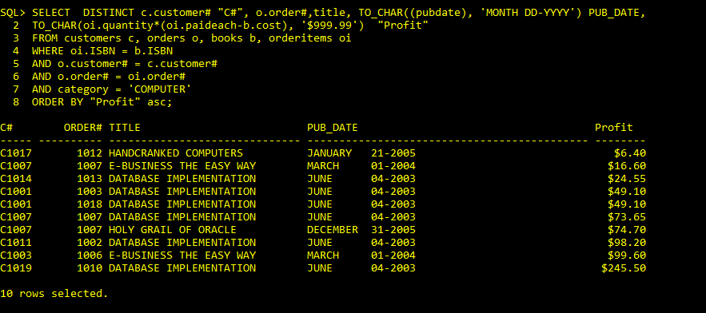

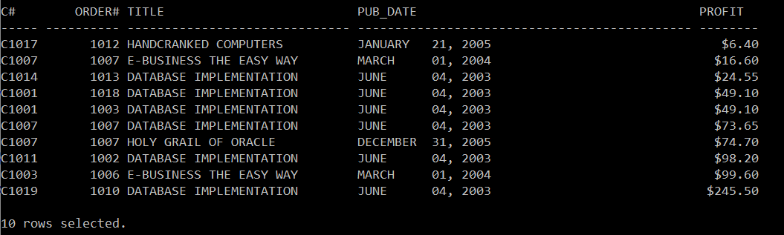

5. Create a query that lists the following information:

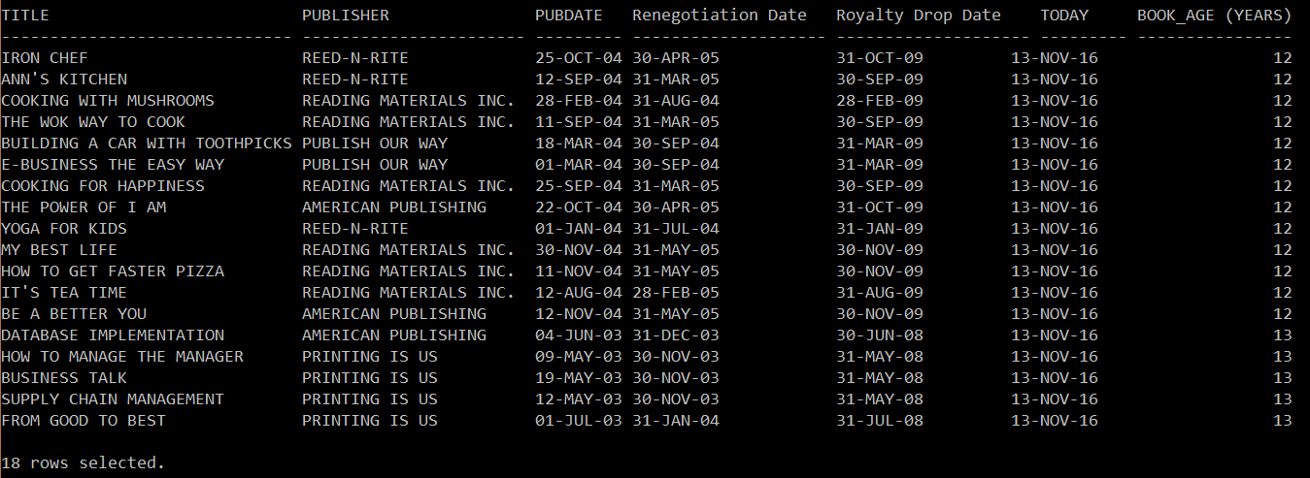

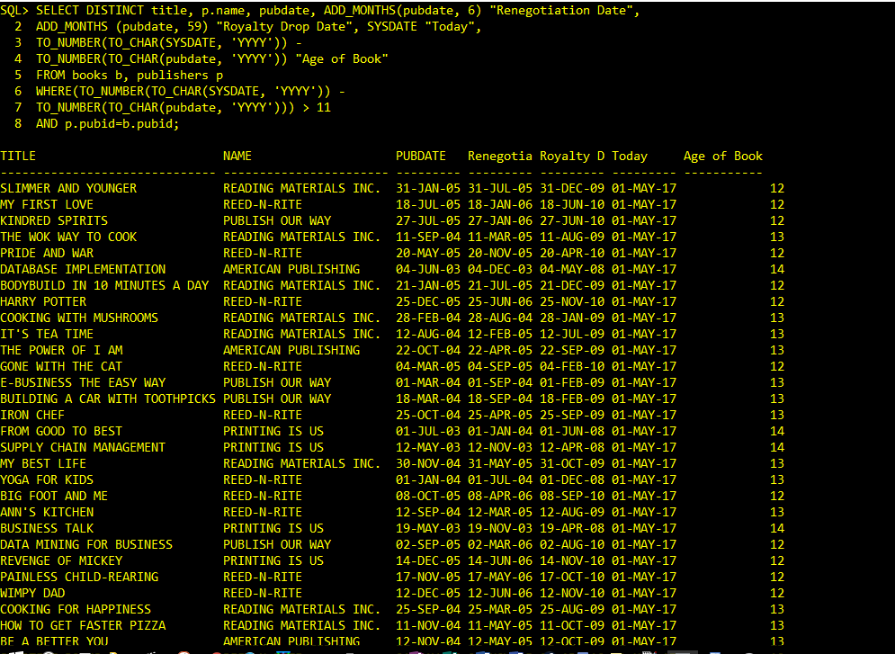

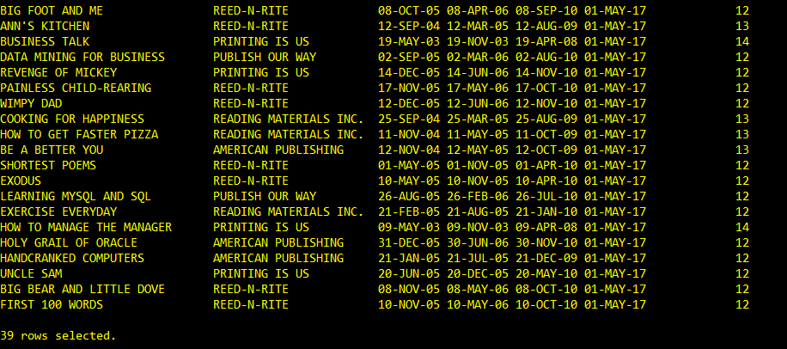

* Using today’s date, determine **the age (years)** of each book. List only those books that were published **more than 11 years ago**. 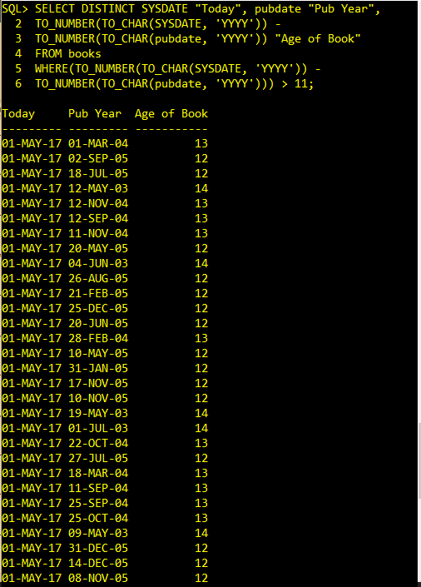

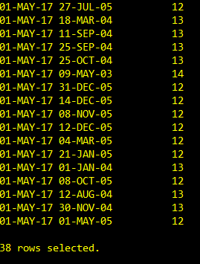

* Each book needs to be evaluated after half a year for renegotiation of royalty payments after it was published. The royalty payments will be drop in the 5th year after the book was published. Figure out the **renegotiation date** and **royalty drop date**
* **The renegotiation and royalty drop dates should always take place on the last day of the specified month.** 